***Logo and address of RTB***

**Trainee Manual Template**

**(Trainee Manual)**

**COVER PAGE**

# Author’s Note Page (Copyright)

# Acknowledgements

The publisher would like to thank the following for their assistance in the elaboration of this textbook:

# Table of content

# Acronyms

# Introduction

Module Code and Title: COASP201 COMPUTER AND ITS PERIPHERALS

|  |
| --- |
| **Learning Outcome 1: Introduce computing fundamentals**  **Learning Outcome 2: Apply Computer Basic Operations**  **Learning Outcome 3: Apply Basic Computer Maintenance** |

# Learning Outcome 1: Introduce computing fundamentals

|  |
| --- |
| **Illustration reflecting the Learning outcome 1** |

|  |
| --- |
| **Indicative contents**   * 1. Description of computer   2. Description of computer network basics   3. Description of computer security |

## Key Competencies for Learning outcome 1:

|  |  |  |  |
| --- | --- | --- | --- |
| **SN** | **Knowledge** | **Skills** | **Attitudes** |
| 1 | Describe a computer |  | Passion |
| 2 | Identify computer parts  to a computer |  | Critical thinking |
| 3 | Differentiate input devices and output devices |  | Curiosity |
| 4 | Describe the types of computer memories |  | Patience |
| 5 | Understand system software and application software |  | Teamwork |
| 6 | Define computer network |  | Punctuality |
| 7 | Classify the computer networks |  | Creativity |
| 8 | Define the internet |  | Multitasking |
| 9 | Describe the network devices |  | Flexibility |
| 10 | Define computer security |  | Self -control |
| 11 | Describe the computer threats |  | Accountability |

|  |  |  |
| --- | --- | --- |
| **Duration: 15 hrs** | | |
| Learning outcome 1 objectives: By the end of the learning outcome, the trainees will be able to:   1. To define clearly computer 2. To description effectively of various main parts 3. To describe effectively types of computer 4. To differentiate appropriately computer peripherals 5. To explain correctly types of computer memory 6. To define clearly computer network 7. To classify efficiently computer network 8. To define clearly internet 9. To differentiate appropriately network devices   10.To enumerate correctly various security threats and ensure security of computer | | |
| **Resources** | | |
| **Equipment** | **Tools** | **Materials** |
| * Computer and all peripherals * Router * Wireless access point * MODEM * Switch * Ethernet cable * UPS | * Application software | * Internet * Electricity * Projector * Notes |

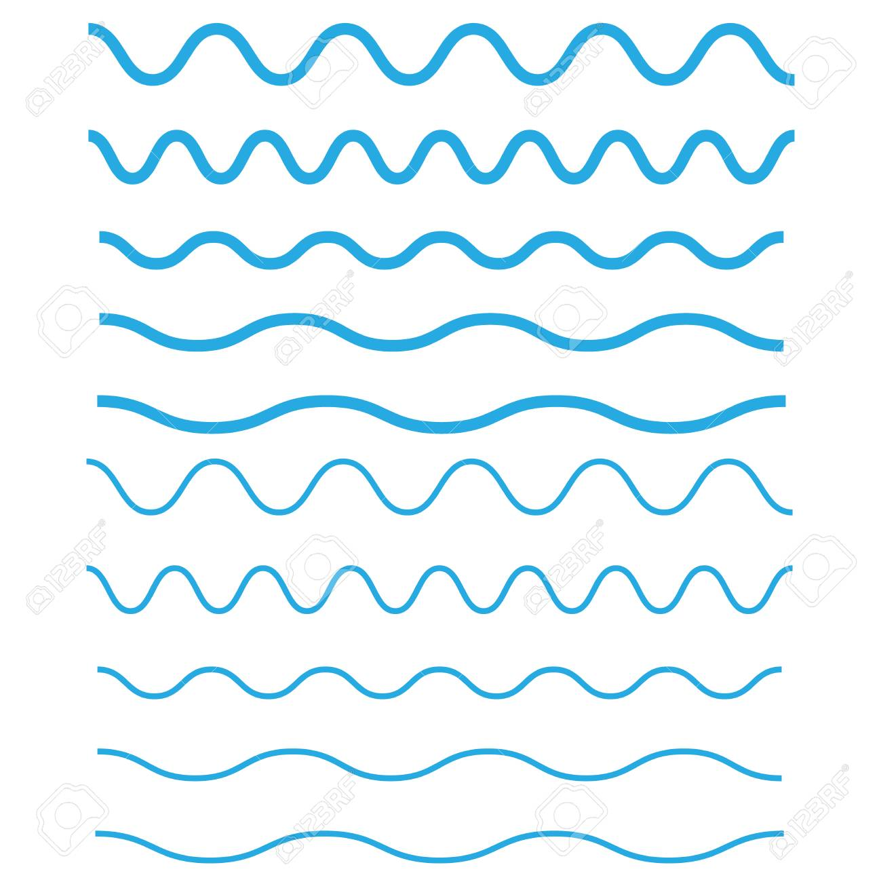

## **Indicative content 1.1:** **Description of computer**

### Theoretical Activity 1.1.1: Introduce computer and its peripherals

**Tasks:**

The school management wants to buy a computer and they need an IT Technician to drafting its technical specifications. After doing discussions in groups, respond to the following questions

**1:** Define a computer

**2:** Describe different types of computer

**3:** Differentiate between software and hardware

**4:** What is the difference between of input device and output device?

**5: How is RAM different from ROM?**

|  |
| --- |
| Refer Instruction Manual Booklet Black Iconvector Illustration Isolated On  White Background Label Eps10 Stock Illustration - Download Image Now -  iStock**Key readings:**   * **Computer** is a programmable electronic device that accepts data as input and processes them with a set of instructions (a program) and produce the result as output.   A **computer** is a [machine](https://en.wikipedia.org/wiki/Machine) that can be programmed to [carry out](https://en.wikipedia.org/wiki/Execution_(computing)) sequences of [arithmetic](https://en.wikipedia.org/wiki/Arithmetic) or [logical operations](https://en.wikipedia.org/wiki/Logical_operations) ([computation](https://en.wikipedia.org/wiki/Computation)) automatically.     * **A computer system** is a set of integrated devices that input, output, process, and store data and information. Computer systems are currently built around at least one digital processing device. There are five main hardware components in a computer system: Input, Processing, Storage, Output and Communication devices.   A **computer system** is a nominally complete computer that includes the [hardware](https://en.wikipedia.org/wiki/Computer_hardware), [operating system](https://en.wikipedia.org/wiki/Operating_system) (main [software](https://en.wikipedia.org/wiki/Software)), and [peripheral](https://en.wikipedia.org/wiki/Peripheral) equipment needed and used for full operation. This term may also refer to a group of computers that are linked and function together, such as a [computer network](https://en.wikipedia.org/wiki/Computer_network) or [computer cluster](https://en.wikipedia.org/wiki/Computer_cluster).   * **Types of computer:** the types of computers are based on size, price and capabilities such as supercomputers, mainframe, minicomputers and microcomputers.  Super computers They are very large in size and use multiple processors and superior technology. Super computers are biggest in size, the most expensive in price than any other is classified and known as super computer. It can process trillions of instructions in seconds. This computer is not used as a PC in a home neither by a student in a college. Governments specially use this type of computer for their different calculations and heavy jobs. Different industries also use this huge computer for designing their products.  **Mainframe computers**  A mainframe is another giant computer after the super computer and can also process millions of instruction per second and capable of accessing billions of data.  They are physically very large in size with very high capacity of main memory. This computer is commonly used in big hospitals, airline reservations companies, and many other huge companies prefer mainframe because of its capability of retrieving data on a huge basis.  They can be linked to smaller computers and handle hundreds of users they are also used in space exploitation. The term mainframe was mainly used for earliest computers as they were big in size though today the term is used to refer to large computers. A large number of peripherals can be attached to them. They are expensive to install.  **Minicomputers**  They are smaller than the main frame but bigger than microcomputers. They support concurrent users. They can be used as servers in companies. They are slower and less costly compared to mainframe computers but more powerful, reliable and expensive than microcomputers.   * **Micro computers**   They are of advanced technology i.e. the micro era based on large scale integration that confines several physical components per small elements thumb size IC, hence the size reduced. It is the smallest of the three computers. They are usually called personal computers since they are designed to be used by individuals. The microchip technology has enabled reduction of size of computers. Microcomputers can be a desktop, laptop, notebooks, or even palmtop   * **Notebook computer** an extremely lightweight personal computer. Notebook computers typically weigh less than 6 pounds and are small enough to fit easily in a briefcase.     Aside from size and portability, Notebook computers use a variety of techniques, known as flat-panel technologies, to produce a lightweight and non-bulky display screen.   * **Desktop Computer** is an independent personal computer that is made especially for use on a desk in an office or home.     The term is used mainly to distinguish this type of personal computer from portable computers and laptops, but also to distinguish other types of computers like the server or mainframe.   * **Laptop** A small portable computer light enough to carry comfortably, with a flat screen and keyboard that fold together.     Laptops are battery operated, often have a thin, backlit or side lit LCD display screen, and some models can even mate with a docking station to perform as a full sized desktop system back at the office. Advances in battery technology allow laptop computers to run for many hours between charges, and some models have a set of business applications built into ROM. Today's high end (Advanced) laptops provide all the capabilities of most desktop computers.   * **Main parts of computer:** there are two main parts of a computer which are hardware and software   **Hardware:** Is a physical part of computer such as Motherboard, Monitor, Keyboard, Mouse, RAM, C.P.U, Power Supply Unit. Hardware refers to all physical components of a computer system, including the devices connected to it. You cannot create a computer or use software without using hardware. The screen on which you are reading this information is also a hardware.    **Software:** is a set of instructions or a collection of programs which developed to perform a specific task. Software is a set of instructions, data or programs used to operate computers and execute specific tasks. It is the opposite of hardware, which describes the physical aspects of a computer. Software is a generic term used to refer to applications, [scripts](https://www.techtarget.com/whatis/definition/script) and programs that run on a device. It can be thought of as the variable part of a computer, while hardware is the invariable part. The two main categories of software are [**application**](https://www.techtarget.com/searchsoftwarequality/definition/application)**software** and [**system software**](https://www.techtarget.com/whatis/definition/system-software)**.** An application is software that fulfills a specific need or performs tasks. System software is designed to run a computer's hardware and provides a platform for applications to run on top of. Other types of software include programming software, which provides the programming tools software developers need; [**middleware**](https://www.techtarget.com/searchapparchitecture/definition/middleware), which sits between system software and applications; and [**driver**](https://www.techtarget.com/searchstorage/definition/driver) software, which operates computer devices and peripherals.   * **Computer peripheral**   **A computer peripheral or a peripheral** is an auxiliary [hardware](https://en.wikipedia.org/wiki/Electronic_hardware) device used to transfer information into and out of a [computer](https://en.wikipedia.org/wiki/Computer). The term peripheral device refers to all hardware components that are attached to a computer and are controlled by the computer system, but they are not the core components of the computer.  Several categories of peripheral devices may be identified, based on their relationship with the computer:   * **An**[**input device**](https://en.wikipedia.org/wiki/Input_device) sends data or instructions to the computer, such as a [mouse](https://en.wikipedia.org/wiki/Computer_mouse), [keyboard](https://en.wikipedia.org/wiki/Computer_keyboard), [graphics tablet](https://en.wikipedia.org/wiki/Graphics_tablet), [image scanner](https://en.wikipedia.org/wiki/Image_scanner), [barcode reader](https://en.wikipedia.org/wiki/Barcode_reader), [game controller](https://en.wikipedia.org/wiki/Game_controller), [light pen](https://en.wikipedia.org/wiki/Light_pen), [light gun](https://en.wikipedia.org/wiki/Light_gun), [microphone](https://en.wikipedia.org/wiki/Microphone) and [webcam](https://en.wikipedia.org/wiki/Webcam). * **An**[**output device**](https://en.wikipedia.org/wiki/Output_device) provides output data from the computer, such as a [computer monitor](https://en.wikipedia.org/wiki/Computer_monitor), [projector](https://en.wikipedia.org/wiki/Projector), [printer](https://en.wikipedia.org/wiki/Printer_(computing)), [headphones](https://en.wikipedia.org/wiki/Headphones) and [computer speaker](https://en.wikipedia.org/wiki/Computer_speakers); * **An input/output device**performs both input and output functions, such as a [computer data storage](https://en.wikipedia.org/wiki/Computer_data_storage) device (including a [disk drive](https://en.wikipedia.org/wiki/Disk_storage), [solid-state drive](https://en.wikipedia.org/wiki/Solid-state_drive), [USB flash drive](https://en.wikipedia.org/wiki/USB_flash_drive), [memory card](https://en.wikipedia.org/wiki/Memory_card) and [tape drive](https://en.wikipedia.org/wiki/Tape_drive)), [modem](https://en.wikipedia.org/wiki/Modem), [network adapter](https://en.wikipedia.org/wiki/Network_adapter) and [multi-function printer](https://en.wikipedia.org/wiki/Multi-function_printer). * **Computer memory:** is the storage space in the computer, where data is to be processed and instructions required for processing are stored. There are two types such as internal memory is also called main memory band external memory is also called secondary memory storage. * **Primary Memory/Main Memory**   Primary Memory consists of the various devices that are able to store data and programs when the power is on means to store data temporarily. Any **data** or **instructions** that are to be **processed** by the CPU must be placed into **main memory** (sometimes known as **primary storage**). Eg: RAM  Both RAM and ROM are the two major classifications of memory. The crucial difference between RAM and ROM is that **RAM is a volatile memory** thus stores data only till the time the power is switched on. While **ROM is a non-volatile** memory that retains data even when the power gets off. Secondary memory Secondary Memory consists of the various devices that are able to store data and programs even when the power is off means to store data permanently. This includes devices such as hard drives, floppy drives, tape drives, CD drives and DVD drives. |

### Practical Activity 1.1.2: ……………………………………………………

**Tasks:** *(These tasks are related and responding to steps in trainer manual)*

**1:**

**2:**

**3:**

**.**

**.**

**n:**

|  |
| --- |
| Refer Instruction Manual Booklet Black Iconvector Illustration Isolated On  White Background Label Eps10 Stock Illustration - Download Image Now -  iStock**Key readings:**  ………………………………………………………………………………………………………………………………………………………..  ………………………………………………………………………………………………………………………………………………………..  ………………………………………………………………………………………………………………………………………………………..  ………………………………………………………………………………………………………………………………………………………..  ………………………………………………………………………………………………………………………………………………………..  ………………………………………………………………………………………………………………………………………………………..  ………………………………………………………………………………………………………………………………………………………..  ………………………………………………………………………………………………………………………………………………………..  ………………………………………………………………………………………………………………………………………………………..  ………………………………………………………………………………………………………………………………………………………..  ………………………………………………………………………………………………………………………………………………………..  ……………………………………………………………………………………………………………………………………………………….. |

### Points to Remember

* **Computer** is a programmable electronic device that accepts data as input and processes them with a set of instructions (a program) and produce the result as output.
* **Types of computer:** supercomputers, mainframe, minicomputers and microcomputers.
* **Main parts of computer:** there are two main parts of a computer which are hardware and software
* **Hardware:** Motherboard, Monitor, Keyboard, Mouse, RAM, C.P.U, Power Supply Unit.
* **Software:** application software and system software
* **Computer peripherals:** input, input/output and output devices.
* **Computer memory:** internal memory and external memory.

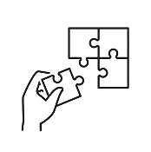Application of learning 1.1

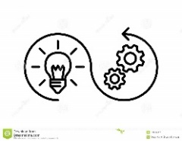**Task:** …………………………………………………………………………………………………………………………………………………………………………………………………………………………………………………………………………………………………………………………………………………………………………………………………………………………………………………………………………………………………………



## Indicative content 1.2: ..........................................

**Duration:.......hr**

### Theoretical Activity 1.2.1: ……………………………………………………

**Tasks:** *(These tasks are related and responding to steps in trainer manual)*

**1:**

**2:**

**3:**

**.**

**.**

**n:**

|  |
| --- |
| Refer Instruction Manual Booklet Black Iconvector Illustration Isolated On  White Background Label Eps10 Stock Illustration - Download Image Now -  iStock**Key readings:**  ………………………………………………………………………………………………………………………………………………………..  ………………………………………………………………………………………………………………………………………………………..  ………………………………………………………………………………………………………………………………………………………..  ………………………………………………………………………………………………………………………………………………………..  ………………………………………………………………………………………………………………………………………………………..  ………………………………………………………………………………………………………………………………………………………..  ………………………………………………………………………………………………………………………………………………………..  ………………………………………………………………………………………………………………………………………………………..  ………………………………………………………………………………………………………………………………………………………..  ………………………………………………………………………………………………………………………………………………………..  ………………………………………………………………………………………………………………………………………………………..  ……………………………………………………………………………………………………………………………………………………….. |

### Practical Activity 1.2.2: ……………………………………………………

**Tasks:** *(These tasks are related and responding to steps in trainer manual)*

**1:**

**2:**

**3:**

**.**

**.**

**n:**

|  |
| --- |
| Refer Instruction Manual Booklet Black Iconvector Illustration Isolated On  White Background Label Eps10 Stock Illustration - Download Image Now -  iStock**Key readings:**  ………………………………………………………………………………………………………………………………………………………..  ………………………………………………………………………………………………………………………………………………………..  ………………………………………………………………………………………………………………………………………………………..  ………………………………………………………………………………………………………………………………………………………..  ………………………………………………………………………………………………………………………………………………………..  ………………………………………………………………………………………………………………………………………………………..  ………………………………………………………………………………………………………………………………………………………..  ………………………………………………………………………………………………………………………………………………………..  ………………………………………………………………………………………………………………………………………………………..  ………………………………………………………………………………………………………………………………………………………..  ………………………………………………………………………………………………………………………………………………………..  ……………………………………………………………………………………………………………………………………………………….. |

### Points to Remember

.

.

.

.

### Application of learning 1.2

**Task:** …………………………………………………………………………………………………………………………………………………………………………………………………………………………………………………………………………………………………………………………………………………………………………………………………………………………………………………………………………………………………………



## Indicative content 1.n: ..........................................

**Duration:.......hr**

### Theoretical Activity 1.n.1: ……………………………………………………

**Tasks:** *(These tasks are related and responding to steps in trainer manual)*

**1:**

**2:**

**3:**

**.**

**.**

**n:**

|  |
| --- |
| Refer Instruction Manual Booklet Black Iconvector Illustration Isolated On  White Background Label Eps10 Stock Illustration - Download Image Now -  iStock**Key readings:**  ………………………………………………………………………………………………………………………………………………………..  ………………………………………………………………………………………………………………………………………………………..  ………………………………………………………………………………………………………………………………………………………..  ………………………………………………………………………………………………………………………………………………………..  ………………………………………………………………………………………………………………………………………………………..  ………………………………………………………………………………………………………………………………………………………..  ………………………………………………………………………………………………………………………………………………………..  ………………………………………………………………………………………………………………………………………………………..  ………………………………………………………………………………………………………………………………………………………..  ………………………………………………………………………………………………………………………………………………………..  ………………………………………………………………………………………………………………………………………………………..  ……………………………………………………………………………………………………………………………………………………….. |

### Practical Activity 1.n.2: ……………………………………………………

**Tasks:** *(These tasks are related and responding to steps in trainer manual)*

**1:**

**2:**

**3:**

**.**

**.**

**n:**

|  |
| --- |
| Refer Instruction Manual Booklet Black Iconvector Illustration Isolated On  White Background Label Eps10 Stock Illustration - Download Image Now -  iStock**Key readings:**  ………………………………………………………………………………………………………………………………………………………..  ………………………………………………………………………………………………………………………………………………………..  ………………………………………………………………………………………………………………………………………………………..  ………………………………………………………………………………………………………………………………………………………..  ………………………………………………………………………………………………………………………………………………………..  ………………………………………………………………………………………………………………………………………………………..  ………………………………………………………………………………………………………………………………………………………..  ………………………………………………………………………………………………………………………………………………………..  ………………………………………………………………………………………………………………………………………………………..  ………………………………………………………………………………………………………………………………………………………..  ………………………………………………………………………………………………………………………………………………………..  ……………………………………………………………………………………………………………………………………………………….. |

### Points to Remember

.

.

.

.

### Application of learning 1.n

**Task:** …………………………………………………………………………………………………………………………………………………………………………………………………………………………………………………………………………………………………………………………………………………………………………………………………………………………………………………………………………………………………………



## Learning outcome 1 end assessment

**Written assessment**

…………………………………………………………………………………………………………………………………………………………………………………………………………………………………………………………………………………………………………………………………………………………………………………………………………………………………………………………………………………………………………

**Practical assessment**

…………………………………………………………………………………………………………………………………………………………………………………………………………………………………………………………………………………………………………………………………………………………………………………………………………………………………………………………………………………………………………

# Learning Outcome 2: ..................

-------------------------------------------------------------------------------------------------------------

|  |
| --- |
| **Illustration reflecting the Learning outcome 2** |

|  |
| --- |
| **Indicative contents**  **2.1**  **2.2**  **2.3**  **2.n** |

## Key Competencies for Learning outcome 2:

|  |  |  |  |
| --- | --- | --- | --- |
| **SN** | **Knowledge** | **Skills** | **Attitudes** |
| 1 |  |  |  |
| 2 |  |  |  |
| 3 |  |  |  |
| n. |  |  |  |

|  |  |  |
| --- | --- | --- |
| **Duration: ……….hrs** | | |
| Learning outcome 2 objectives: By the end of the learning outcome, the trainees will be able to:  1. ………………………………….  2. ………………………………….  3. ………………………………….  .  n. ………………………………… | | |
| **Resources** | | |
| **Equipment** | **Tools** | **Materials** |
|  |  |  |
| **Advance preparation:**  .  .  . | | |



## Indicative content 2.1: ..........................................

### Theoretical Activity 2.1.1: ……………………………………………………

**Tasks:** *(These tasks are related and responding to steps in trainer manual)*

**1:**

**2:**

**3:**

**.**

**.**

**n:**

|  |
| --- |
| Refer Instruction Manual Booklet Black Iconvector Illustration Isolated On  White Background Label Eps10 Stock Illustration - Download Image Now -  iStock**Key readings:**  ………………………………………………………………………………………………………………………………………………………..  ………………………………………………………………………………………………………………………………………………………..  ………………………………………………………………………………………………………………………………………………………..  ………………………………………………………………………………………………………………………………………………………..  ………………………………………………………………………………………………………………………………………………………..  ………………………………………………………………………………………………………………………………………………………..  ………………………………………………………………………………………………………………………………………………………..  ………………………………………………………………………………………………………………………………………………………..  ………………………………………………………………………………………………………………………………………………………..  ………………………………………………………………………………………………………………………………………………………..  ………………………………………………………………………………………………………………………………………………………..  ……………………………………………………………………………………………………………………………………………………….. |

### Practical Activity 2.1.2: ……………………………………………………

**Tasks:** *(These tasks are related and responding to steps in trainer manual)*

**1:**

**2:**

**3:**

**.**

**.**

**n:**

|  |
| --- |
| Refer Instruction Manual Booklet Black Iconvector Illustration Isolated On  White Background Label Eps10 Stock Illustration - Download Image Now -  iStock**Key readings:**  ………………………………………………………………………………………………………………………………………………………..  ………………………………………………………………………………………………………………………………………………………..  ………………………………………………………………………………………………………………………………………………………..  ………………………………………………………………………………………………………………………………………………………..  ………………………………………………………………………………………………………………………………………………………..  ………………………………………………………………………………………………………………………………………………………..  ………………………………………………………………………………………………………………………………………………………..  ………………………………………………………………………………………………………………………………………………………..  ………………………………………………………………………………………………………………………………………………………..  ………………………………………………………………………………………………………………………………………………………..  ………………………………………………………………………………………………………………………………………………………..  ……………………………………………………………………………………………………………………………………………………….. |

### Points to Remember

.

.

.

.

### Application of learning 2.1

**Task:** …………………………………………………………………………………………………………………………………………………………………………………………………………………………………………………………………………………………………………………………………………………………………………………………………………………………………………………………………………………………………………



## Indicative content 2.2: ..........................................

**Duration:.......hr**

### Theoretical Activity 2.2.1: ……………………………………………………

**Tasks:** *(These tasks are related and responding to steps in trainer manual)*

**1:**

**2:**

**3:**

**.**

**.**

**n:**

|  |
| --- |
| Refer Instruction Manual Booklet Black Iconvector Illustration Isolated On  White Background Label Eps10 Stock Illustration - Download Image Now -  iStock**Key readings:**  ………………………………………………………………………………………………………………………………………………………..  ………………………………………………………………………………………………………………………………………………………..  ………………………………………………………………………………………………………………………………………………………..  ………………………………………………………………………………………………………………………………………………………..  ………………………………………………………………………………………………………………………………………………………..  ………………………………………………………………………………………………………………………………………………………..  ………………………………………………………………………………………………………………………………………………………..  ………………………………………………………………………………………………………………………………………………………..  ………………………………………………………………………………………………………………………………………………………..  ………………………………………………………………………………………………………………………………………………………..  ………………………………………………………………………………………………………………………………………………………..  ……………………………………………………………………………………………………………………………………………………….. |

### Practical Activity 2.2.2: ……………………………………………………

**Tasks:** *(These tasks are related and responding to steps in trainer manual)*

**1:**

**2:**

**3:**

**.**

**.**

**n:**

|  |
| --- |
| Refer Instruction Manual Booklet Black Iconvector Illustration Isolated On  White Background Label Eps10 Stock Illustration - Download Image Now -  iStock**Key readings:**  ………………………………………………………………………………………………………………………………………………………..  ………………………………………………………………………………………………………………………………………………………..  ………………………………………………………………………………………………………………………………………………………..  ………………………………………………………………………………………………………………………………………………………..  ………………………………………………………………………………………………………………………………………………………..  ………………………………………………………………………………………………………………………………………………………..  ………………………………………………………………………………………………………………………………………………………..  ………………………………………………………………………………………………………………………………………………………..  ………………………………………………………………………………………………………………………………………………………..  ………………………………………………………………………………………………………………………………………………………..  ………………………………………………………………………………………………………………………………………………………..  ……………………………………………………………………………………………………………………………………………………….. |

### Points to Remember

.

.

.

.

### Application of learning 2.2

**Task:** …………………………………………………………………………………………………………………………………………………………………………………………………………………………………………………………………………………………………………………………………………………………………………………………………………………………………………………………………………………………………………



## Indicative content 2.n: ..........................................

**Duration:.......hr**

### Theoretical Activity 2.n.1: ……………………………………………………

**Tasks:** *(These tasks are related and responding to steps in trainer manual)*

**1:**

**2:**

**3:**

**.**

**.**

**n:**

|  |
| --- |
| Refer Instruction Manual Booklet Black Iconvector Illustration Isolated On  White Background Label Eps10 Stock Illustration - Download Image Now -  iStock**Key readings:**  ………………………………………………………………………………………………………………………………………………………..  ………………………………………………………………………………………………………………………………………………………..  ………………………………………………………………………………………………………………………………………………………..  ………………………………………………………………………………………………………………………………………………………..  ………………………………………………………………………………………………………………………………………………………..  ………………………………………………………………………………………………………………………………………………………..  ………………………………………………………………………………………………………………………………………………………..  ………………………………………………………………………………………………………………………………………………………..  ………………………………………………………………………………………………………………………………………………………..  ………………………………………………………………………………………………………………………………………………………..  ………………………………………………………………………………………………………………………………………………………..  ……………………………………………………………………………………………………………………………………………………….. |

### Practical Activity 2.n.2: ……………………………………………………

**Tasks:** *(These tasks are related and responding to steps in trainer manual)*

**1:**

**2:**

**3:**

**.**

**.**

**n:**

|  |
| --- |
| Refer Instruction Manual Booklet Black Iconvector Illustration Isolated On  White Background Label Eps10 Stock Illustration - Download Image Now -  iStock**Key readings:**  ………………………………………………………………………………………………………………………………………………………..  ………………………………………………………………………………………………………………………………………………………..  ………………………………………………………………………………………………………………………………………………………..  ………………………………………………………………………………………………………………………………………………………..  ………………………………………………………………………………………………………………………………………………………..  ………………………………………………………………………………………………………………………………………………………..  ………………………………………………………………………………………………………………………………………………………..  ………………………………………………………………………………………………………………………………………………………..  ………………………………………………………………………………………………………………………………………………………..  ………………………………………………………………………………………………………………………………………………………..  ………………………………………………………………………………………………………………………………………………………..  ……………………………………………………………………………………………………………………………………………………….. |

### Points to Remember

.

.

.

.

### Application of learning 2.n

**Task:** …………………………………………………………………………………………………………………………………………………………………………………………………………………………………………………………………………………………………………………………………………………………………………………………………………………………………………………………………………………………………………



## Learning outcome 2 end assessment

**Written assessment**

…………………………………………………………………………………………………………………………………………………………………………………………………………………………………………………………………………………………………………………………………………………………………………………………………………………………………………………………………………………………………………

**Practical assessment**

…………………………………………………………………………………………………………………………………………………………………………………………………………………………………………………………………………………………………………………………………………………………………………………………………………………………………………………………………………………………………………